Quick sort:

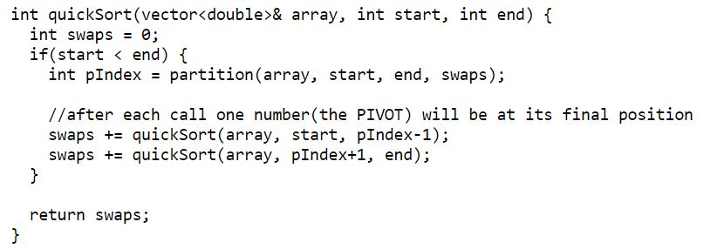

std::map<key_type, value_type> var_name

std::pair< key_type, value_type>

Map search, insert and erase => 0(logn)

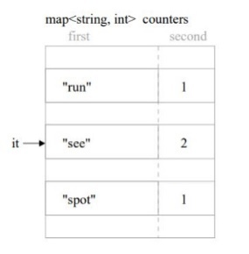

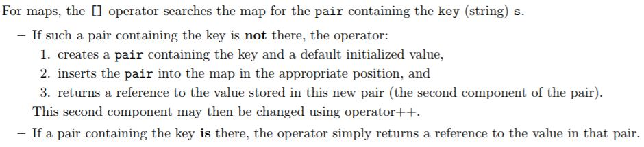

std::map<std::string, int>::const_iterator it;

it->first it -> second

*m.find(key) m.insert(std::make_pair(key, value));*

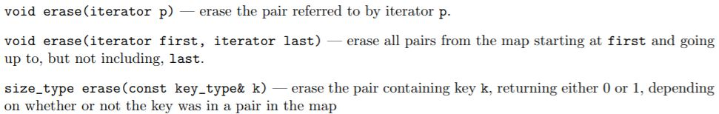std::pair<map<key_type, value_type>::iterator, bool>

map < string, vector<int> > :: const_iterator p;

typedef map < string, vector<int> > map_vect;

map_vect :: const_iterator p;

set:

for (set<string>::iterator p = words.begin(); p!= words.end(); ++p) cout << *p << endl; s.insert(*it)

size_type set<key>::erase(const Key& x);

void set<key>::erase(iterator p);

void set<key>::erase(iterator first, iterator last);

insert find 复杂度同map

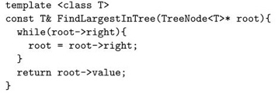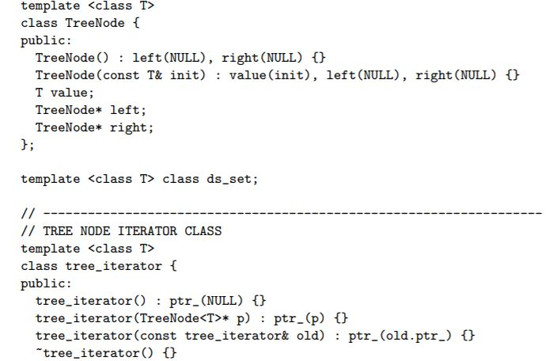

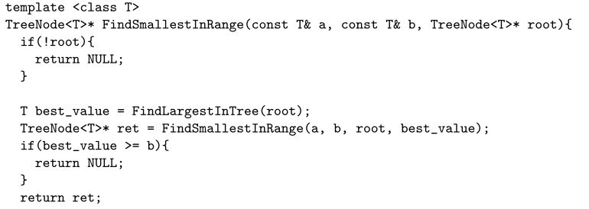

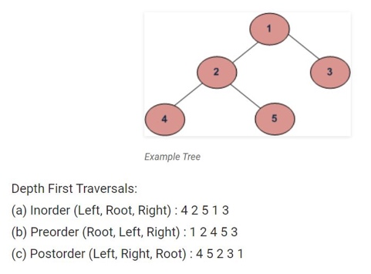

void Rope::destroy_tree(Node* p)

{ if (!p) return;

destroy_tree(p->left);

//move the iterator before delete the Node

Node* tmp = p->right;

delete p;

destroy_tree(tmp);}

Node* Rope::copy_tree(Node* p){

if (p == NULL) return NULL;

else{

Node* copy = new Node;

copy -> weight = p->weight;

copy -> value = p->value;

copy -> left = copy_tree(p->left);

if (copy->left != NULL){

copy->left->parent = copy;

}

copy -> right = copy_tree(p->right);

if (copy->right != NULL){

copy->right->parent = copy;

}

return copy;

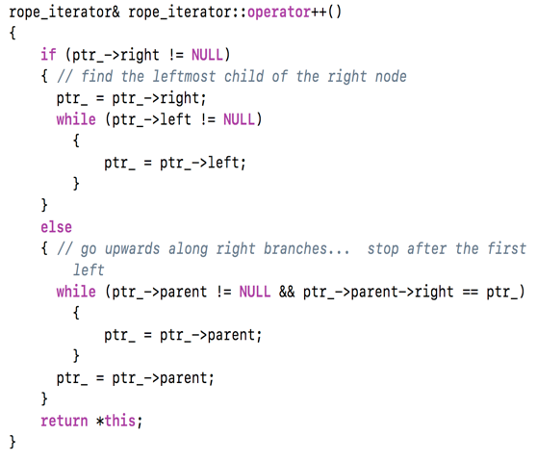 }

}

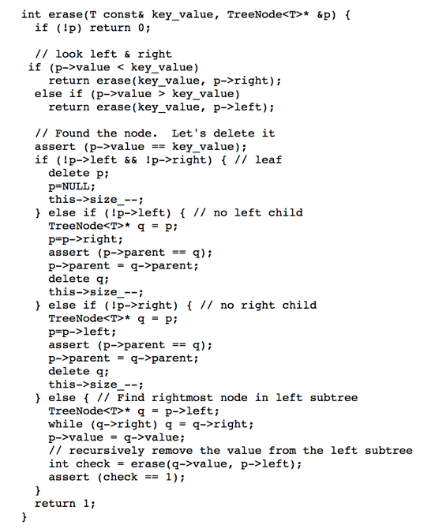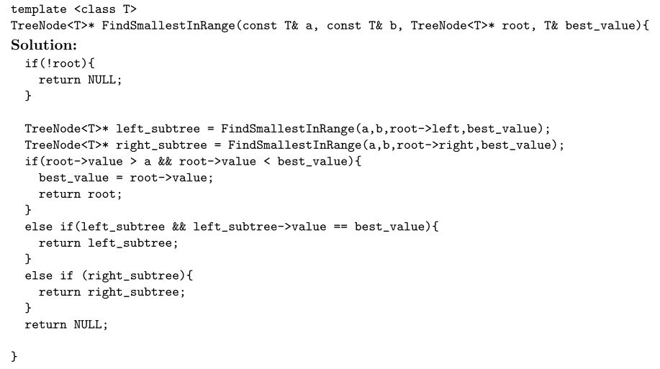

Tree sort:

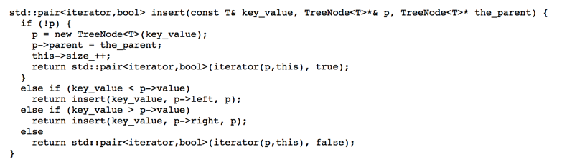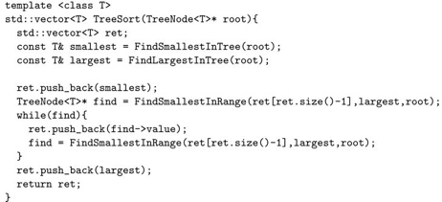

在string查找char:

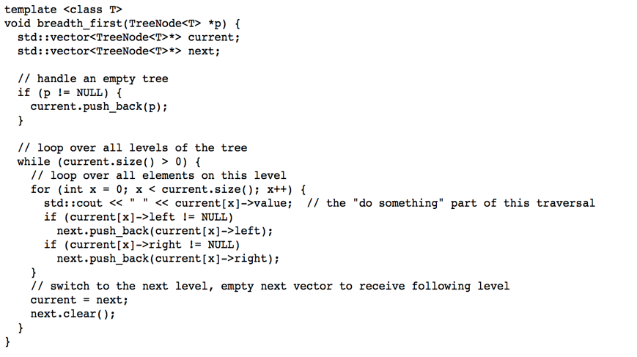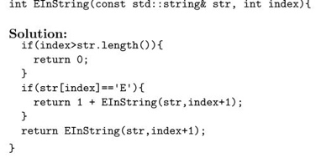

|  |  |  |  |
| --- | --- | --- | --- |
|  | Vector | Singled-linked list | STL list |
| size | √ O(1) | √ O(n) | O(1) |
| push_back | √ O(1) | √ O(n) | O(1) |
| push_front |  | √ O(1) | O(1) |
| pop_back | √ O(1) | √ O(n) | O(1) |
| pop_front |  | √ O(1) | O(1) |
| erase | √ O(n) | √ O(1) | O(1) |
| insert | √ O(n) | √ O(1) | O(1) |

